Introduction:

This is a continuity where I wanted to work for developing a website. This website name is Annual Charity Show (ACS).

ACS (Annual Charity Show) this charity show mainly work for animal and they wanted to ensure animal extra facilities. The Animal charity show (ACS) wanted to develop their charity for this reason every year they promote a charity show. This charity show only for animal. For this charity show many different country are growth their help and sum up fund for this community. The website designed with 7 HTML pages as follows:

* Home
* Charity Events
* Fund Raising
* Community
* News & Reviews
* Tools & Calculators
* Join Us Now

Task-03:

HTML and CSS validation:

For this Annual charity show, this is too much needed that all tasked are show and checked the HTML and CSS pages with W3C validator (<http://validator.w3.org/>) and for mobile web to checked this in (mobile.css-validator.org). when complete this work that moment we say this is valid . when it is complete then we need all pages are run in Google Chrome and Mozilla Firefox and must be it was 1024x768 exploration as it was instructed.in the final moment I marked the all result. Results are shown below:

CSS Validation Screenshot:

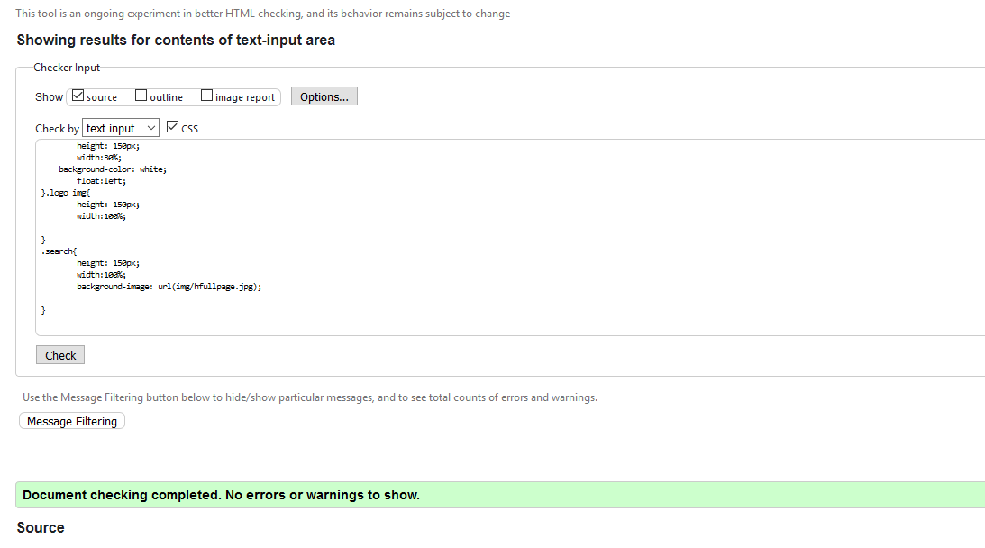

HTML Validation Screenshot:

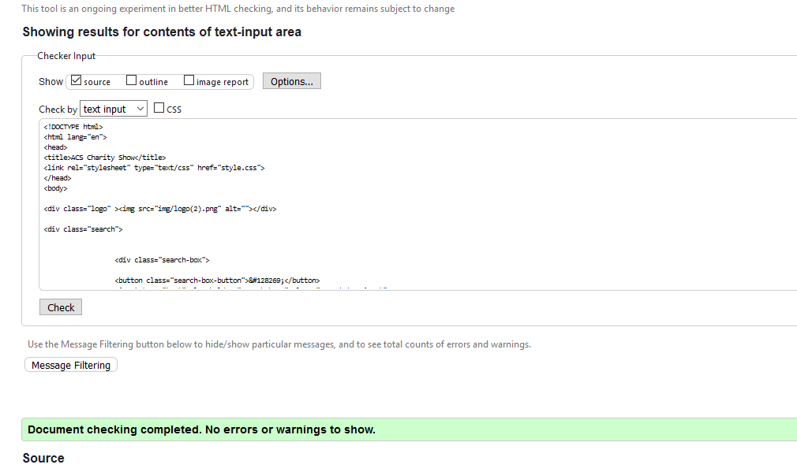

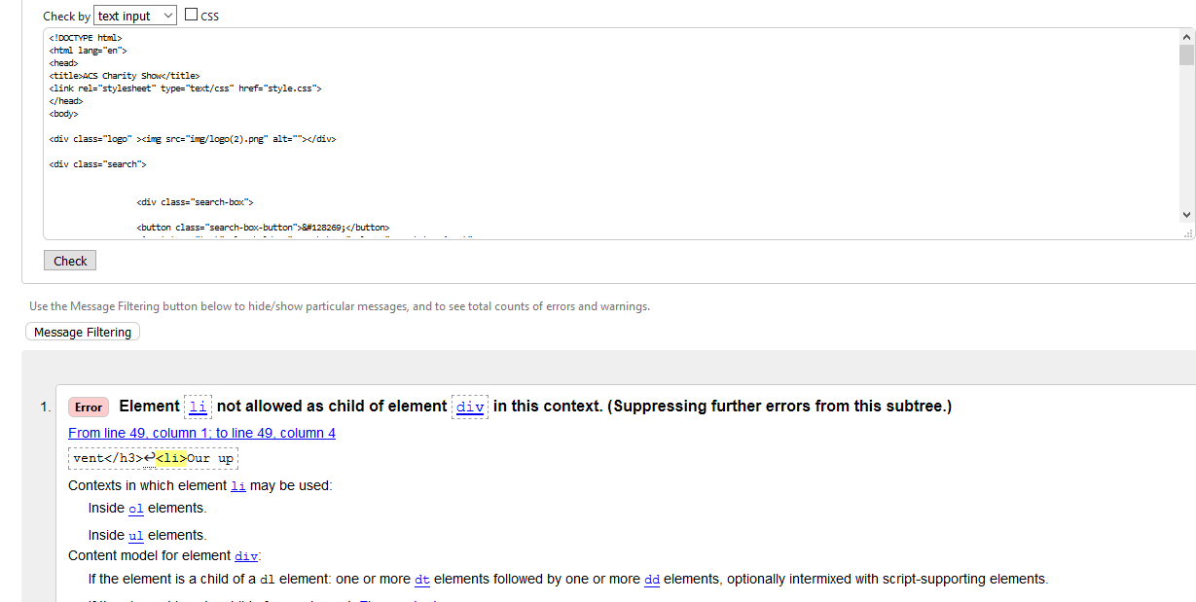It has one error.<li>not allow of element div in this contest.

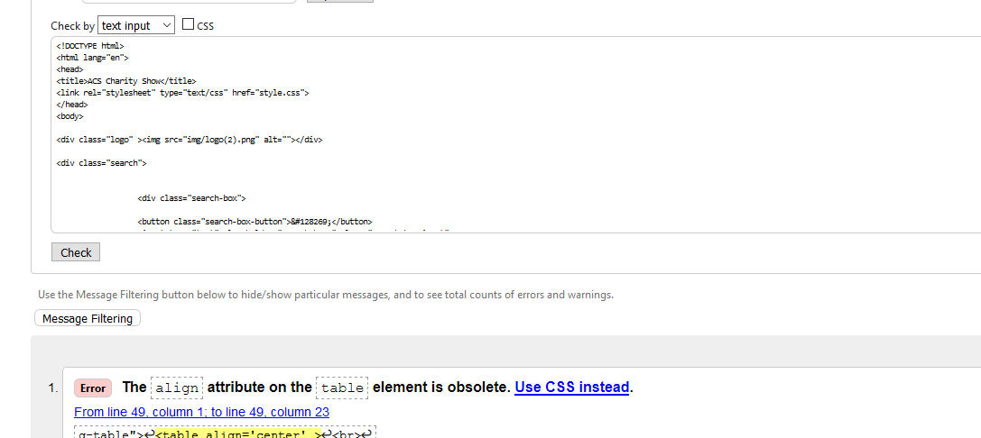

It has one error. align is css element so it never allow in html.

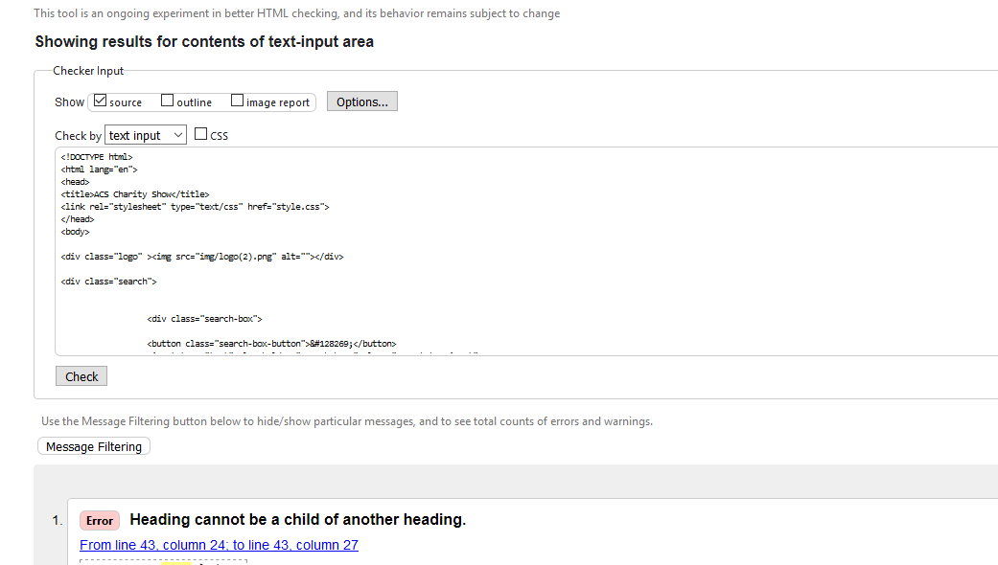

Heading cannot be a child of another heading

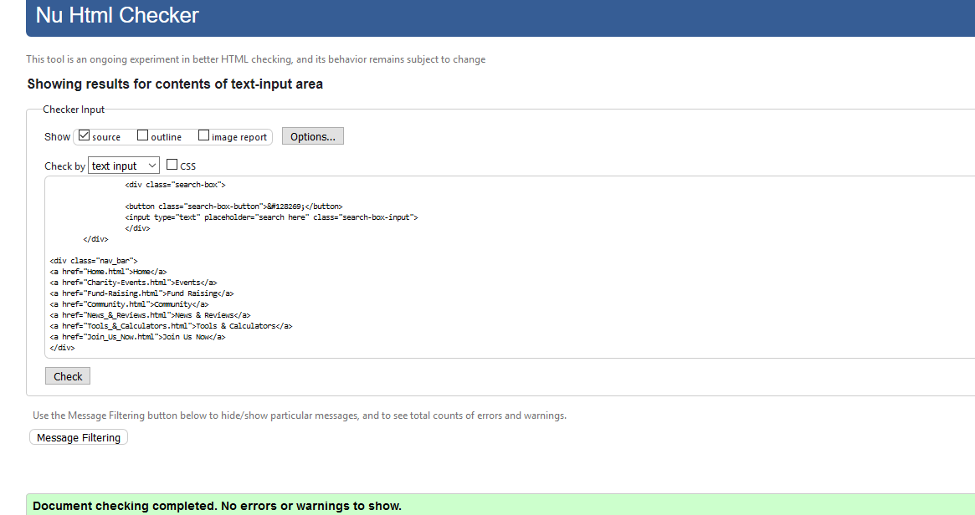

It have not any error..

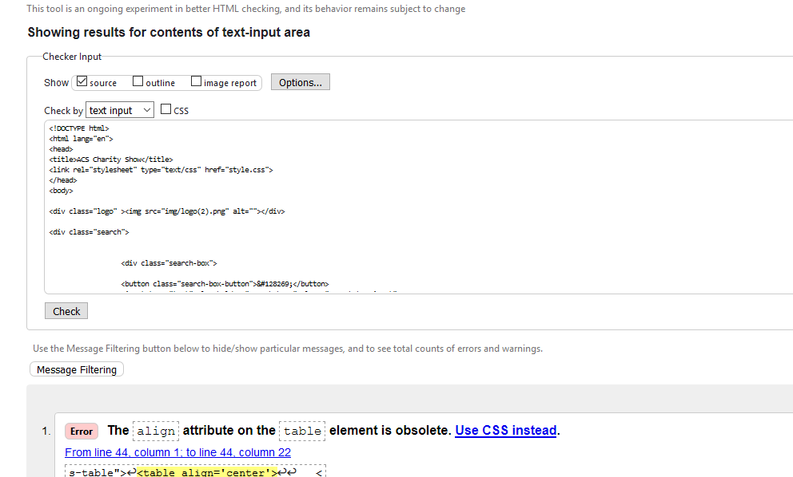

Align attribute is not allow in html.

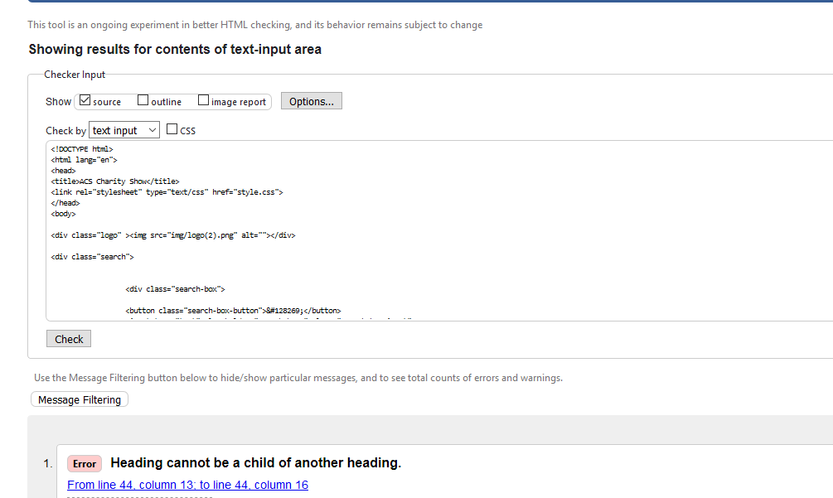

Heading cannot be a child of another heading.

Validation of Mobile.

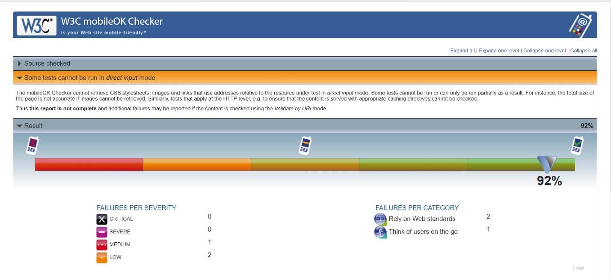

Compatibility of Web Browser -

Google Chrome:

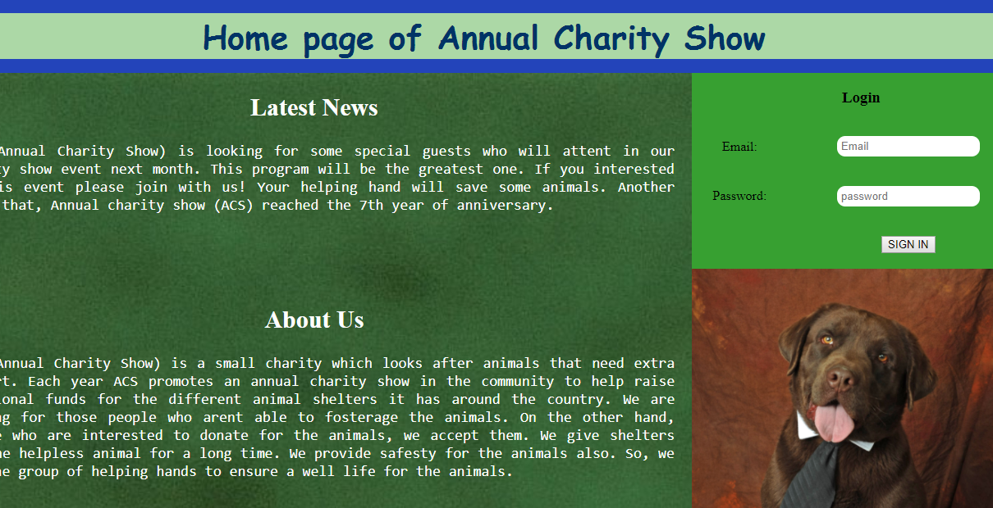

Homepage

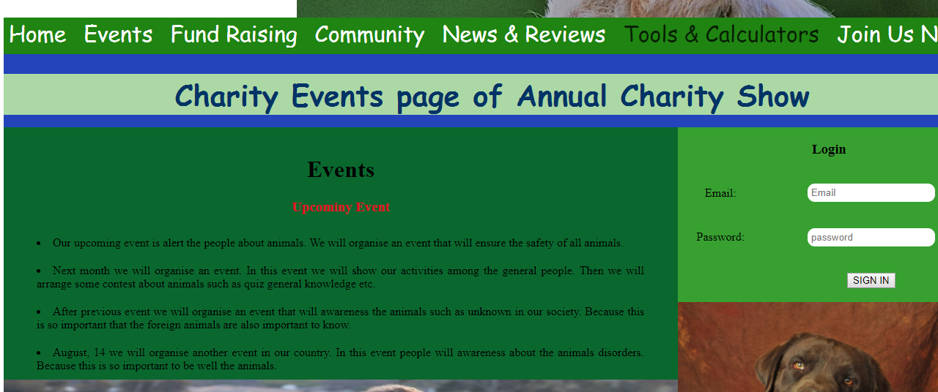

Charity Events page

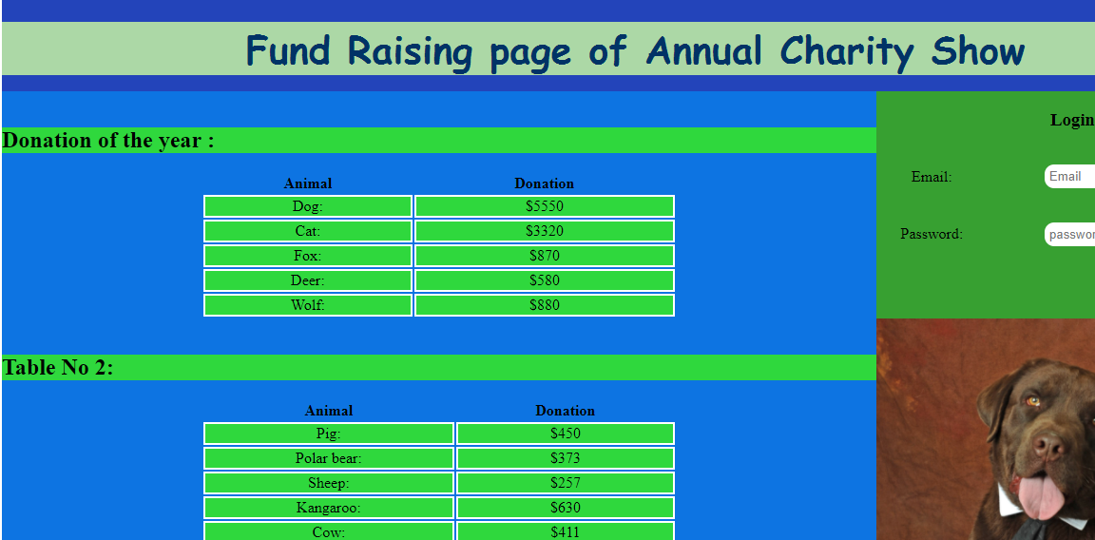

Fund Raising page

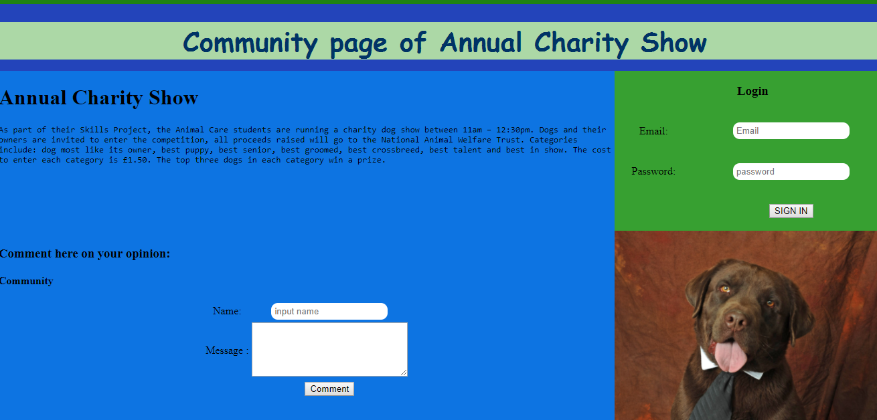

Community page

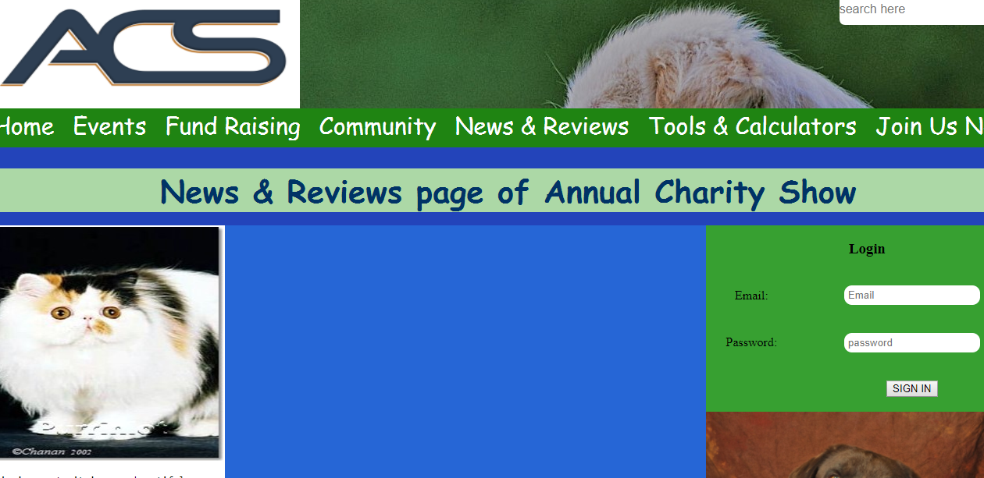

News & Reviews page

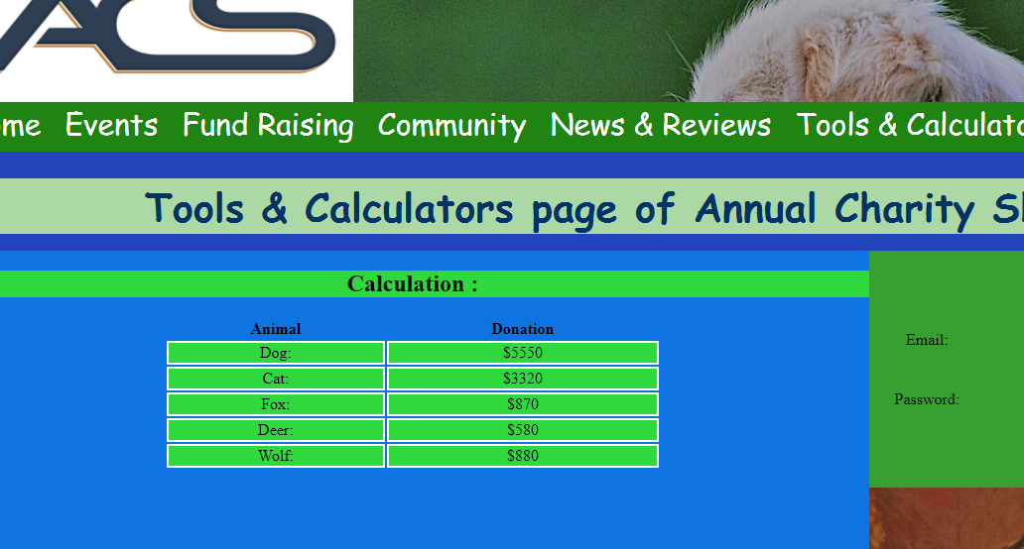

Tools & Calculators page

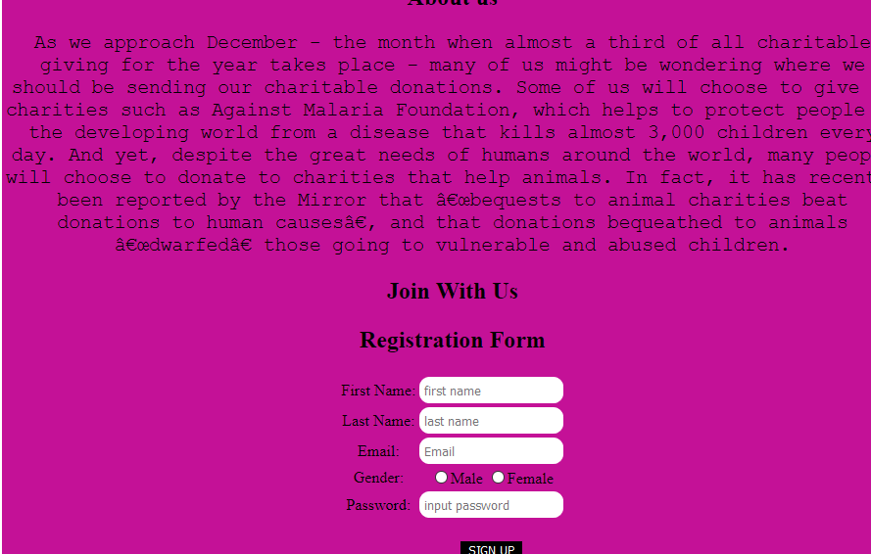

Join Us Now page

Mozilla Firefox:

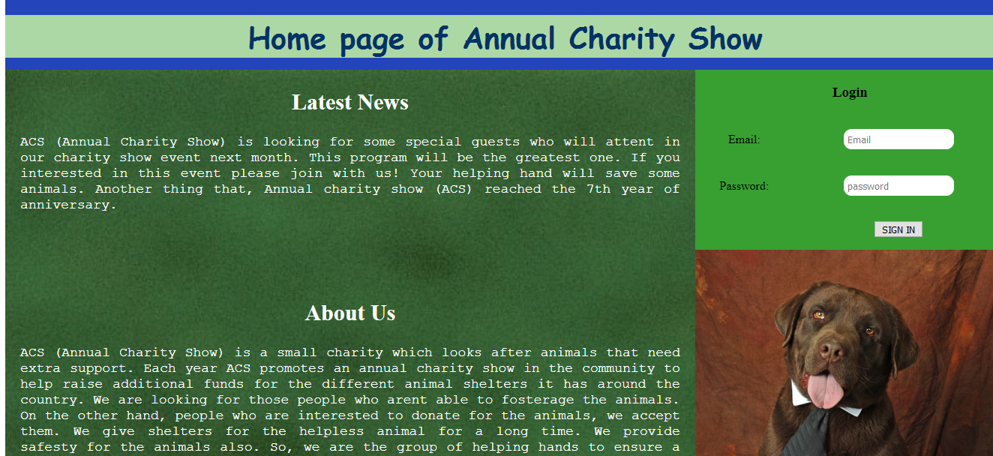

Homepage

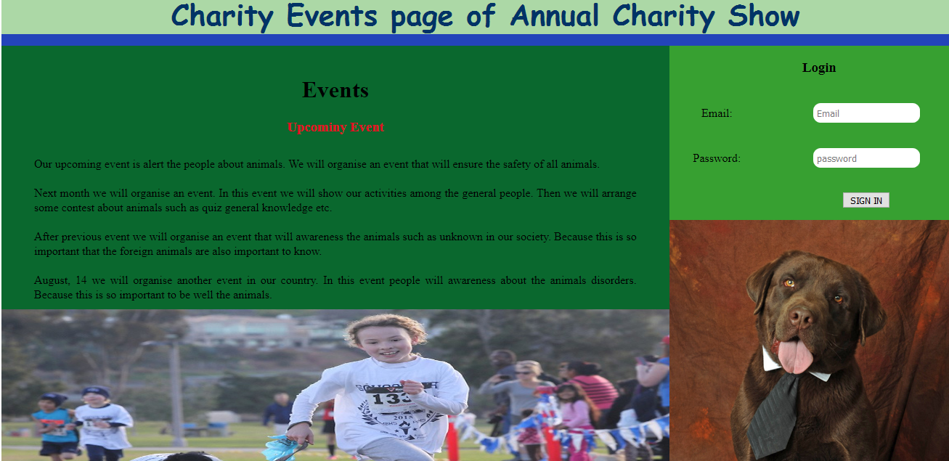

Charity Events page

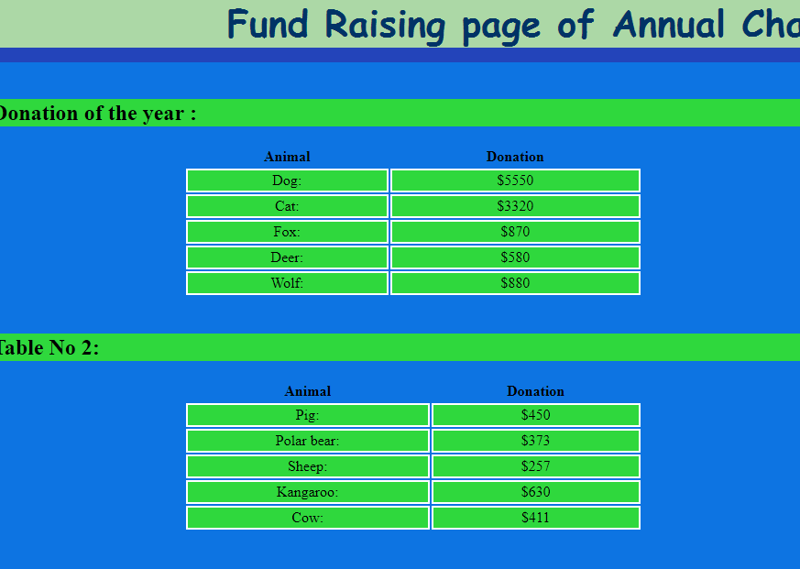

Fund Raising page

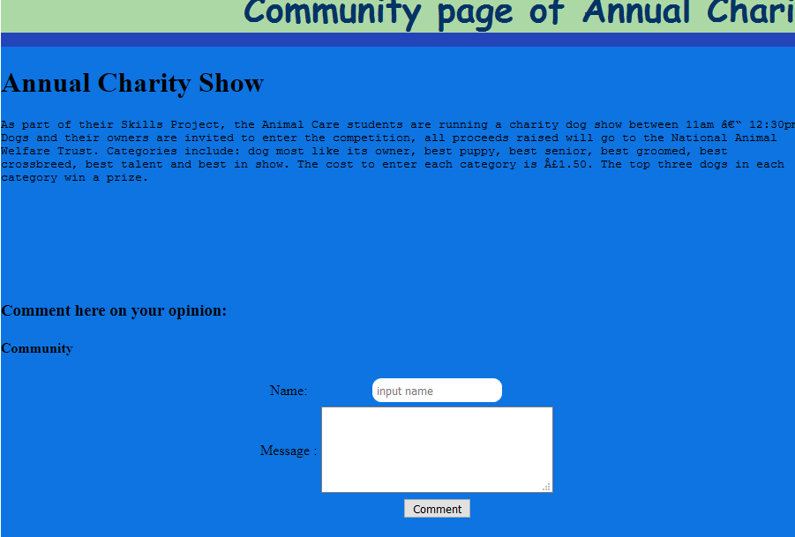

Community page

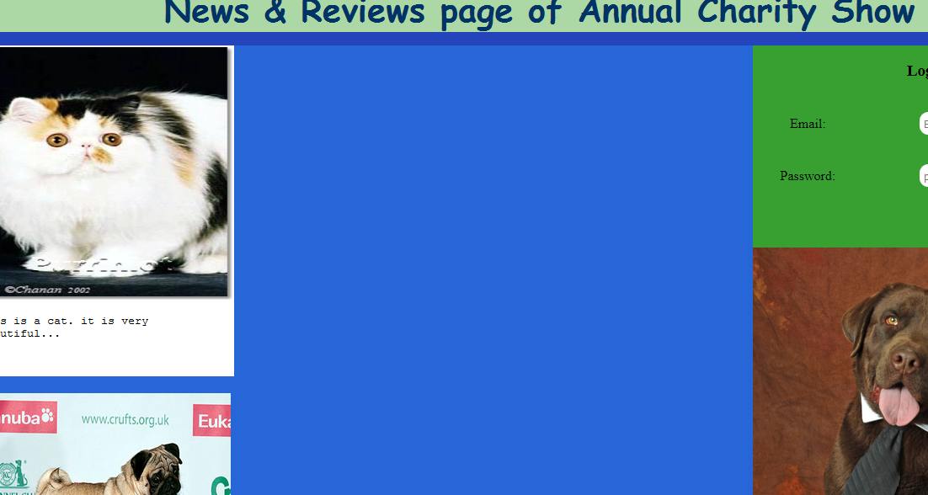

News & Reviews page

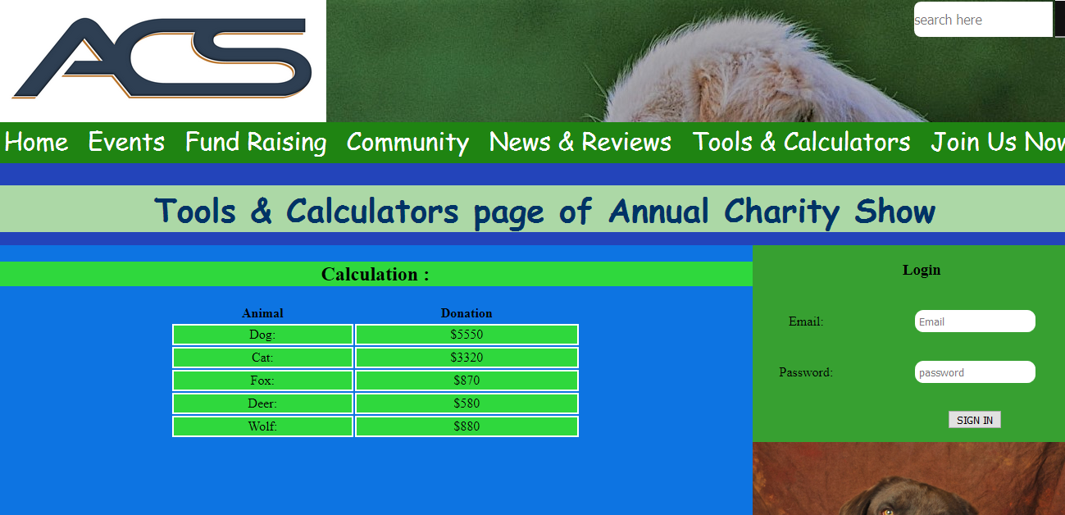

Tools & Calculators page



Join Us Now page

Testing Report:

* I am face some problem, hopefully as soon as possible I solve my problem. When I run this Annual Charity Show file for checked in W3C validator then I saw some different figure between Chrome and Mozilla Firefox. The font size have some variation and I also slow the text size have variation between two browers.

Task-4

Advantage and disadvantage of multimedia element:

|  |  |  |  |
| --- | --- | --- | --- |
| **Element Name** | **Element Format** | **Advantages** | **Disadvantages** |
| Image | Png | Image quality is standard. Quality is not change compress in any ratio | It cannot store multiple image in one file |
| Jpg/jpeg | Image quality is very high with tiny degree of compression. | It image quality is block of 8*8 pixel |
| Video | Mp4 | Less loss compression. | Files are not easy to edit or update. |
| WebM | For internet steaming it was build | All browser are not support this WebM. |

Different types of multimedia file format.

Advantages:

* It can make a greater impression.
* Adding multimedia elements, when viewer are view this elements they must be impress.
* Animations, when it is work for computer then it make all page very attracting and beautiful.

Disadvantages:

* Take more time to loading a video or audio file.
* Multimedia elements not as widely supported in every browser.

ACS website.

Advantages:

* When user can use navigation bar they must be move easily from one page to another page.
* User can do log in to social media, this is very easy for a user to using social media icon.
* 1024x768 size is perfect for this website and it was key with vertically move.

Disadvantages:

* HTML5 and CSS3 language is used for deigned this website only. For using JavaScript, we develop and too much attractive in this website.
* It have not used any map.

Suggestion for Improvements:

* If we realize that this is too much need for more attractive and need to develop we use some language. This language is JavaScript, WordPress, and jQuery etc.
* If we want to more efficiently then we need to adding some navigation bar..

Further Developments:

* If we want to this website is more and more attracting then need to use JAVA and PHP language with HTML and CSS.
* If we linking this website to another websites it must be provide search engine result.

CSS3 for Mobile.

Advantages:

* It makes the website move quickly.
* If we want to this website is done by responsive to mobile devices then we need to use CSS3.
* It helps improve to site speed.
* Mobile user can easily and quickly run and visit the site in mobile

Disadvantages:

* Is does not cover all requirement to respond in mobile.

Conclusion:

In this document I have already describe all component whose are needed for this task. I hope this website help the ACS company finally they are benefited.